

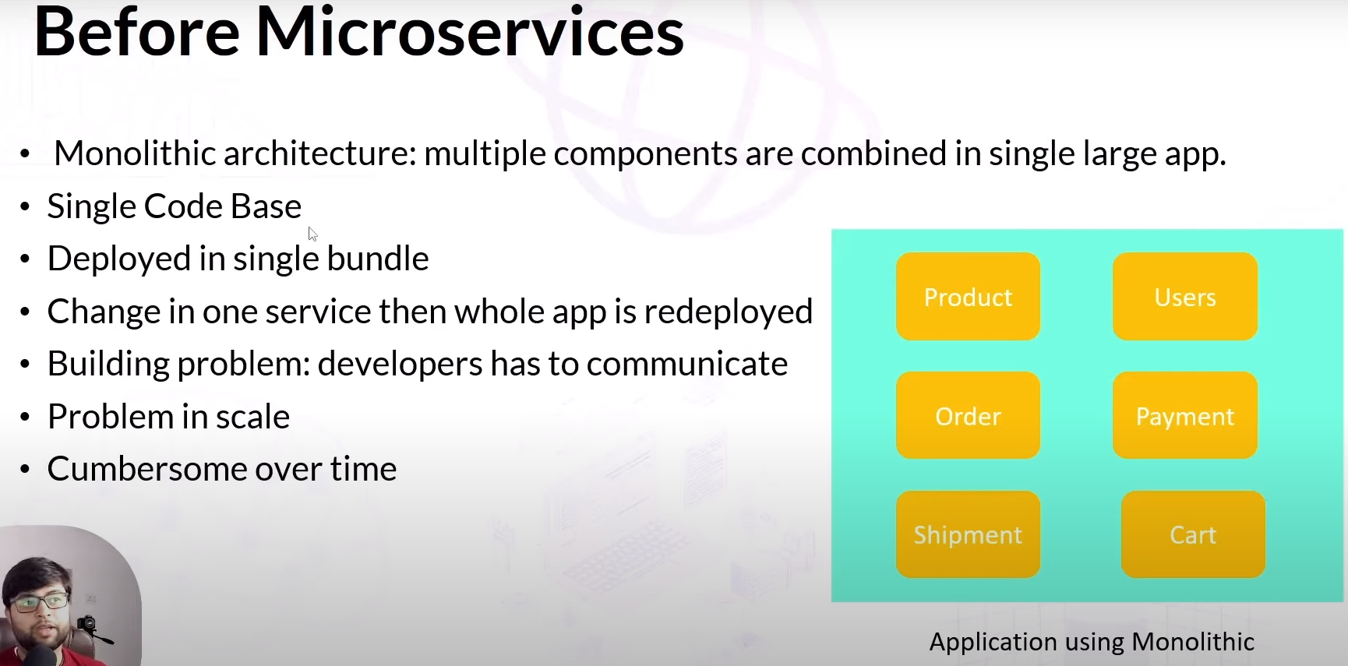

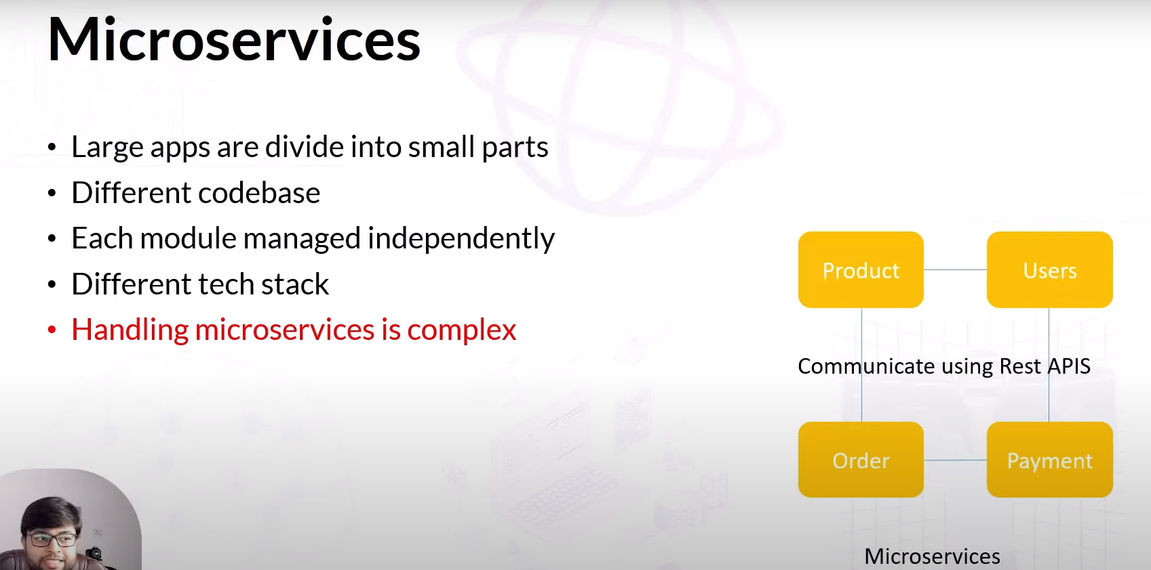

There are many ways to communicate each other of modules. One is Rest Api

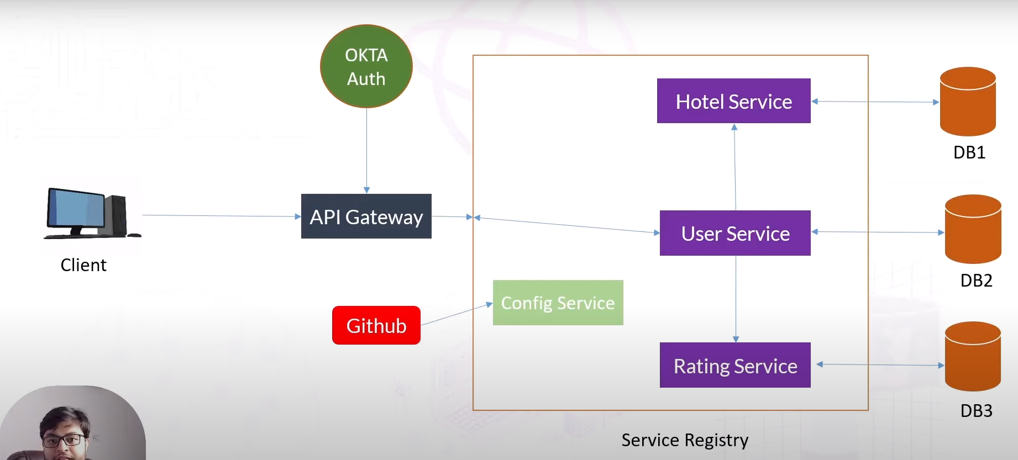

Config Server is used for common configuration of services. We can do this using github.

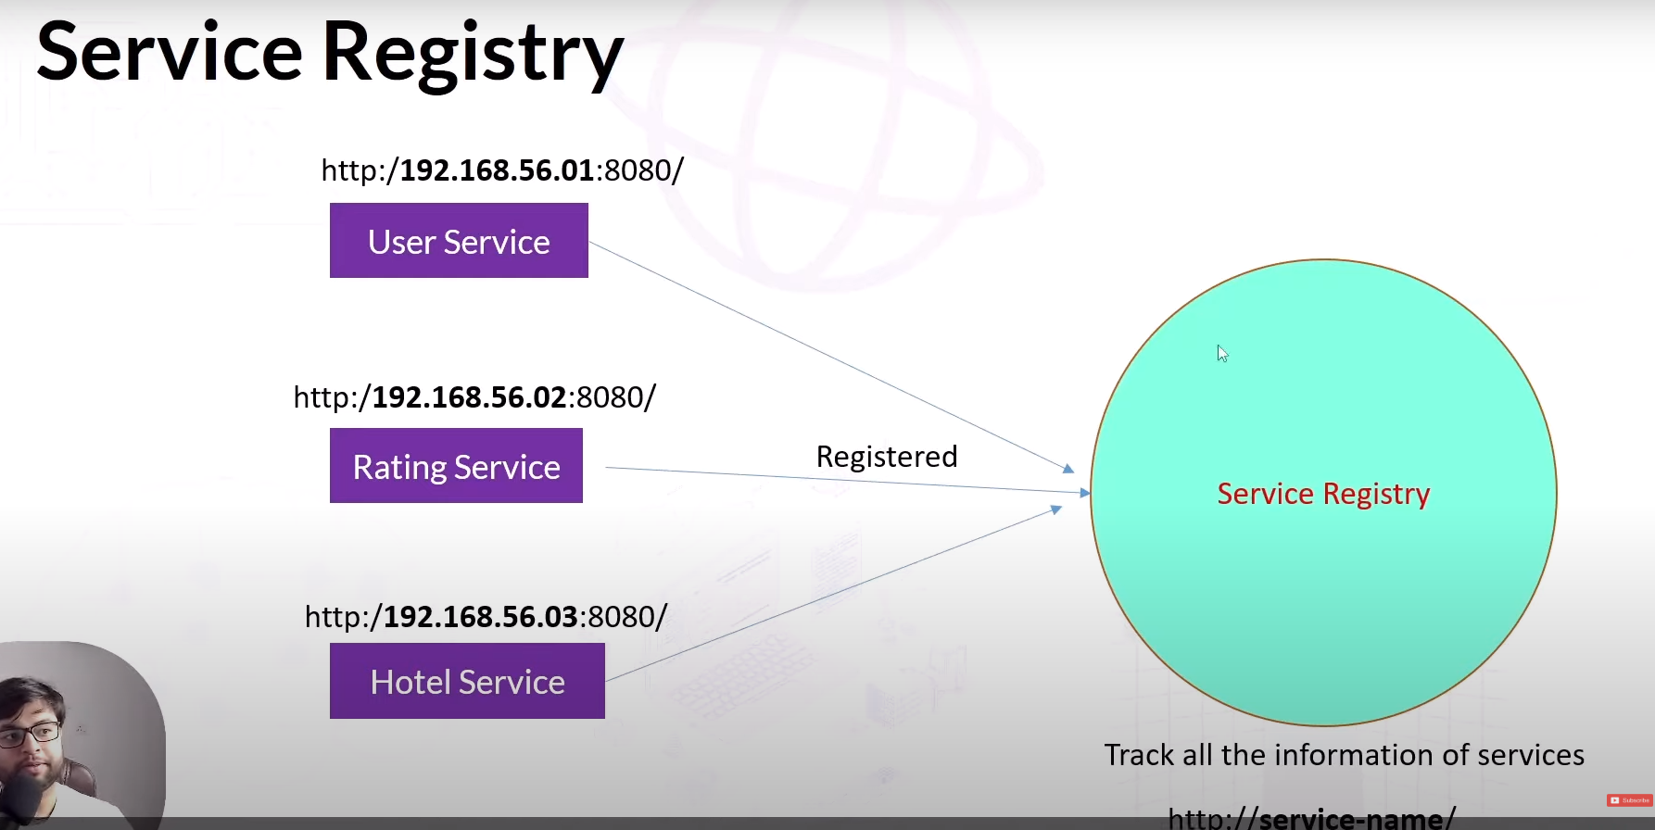

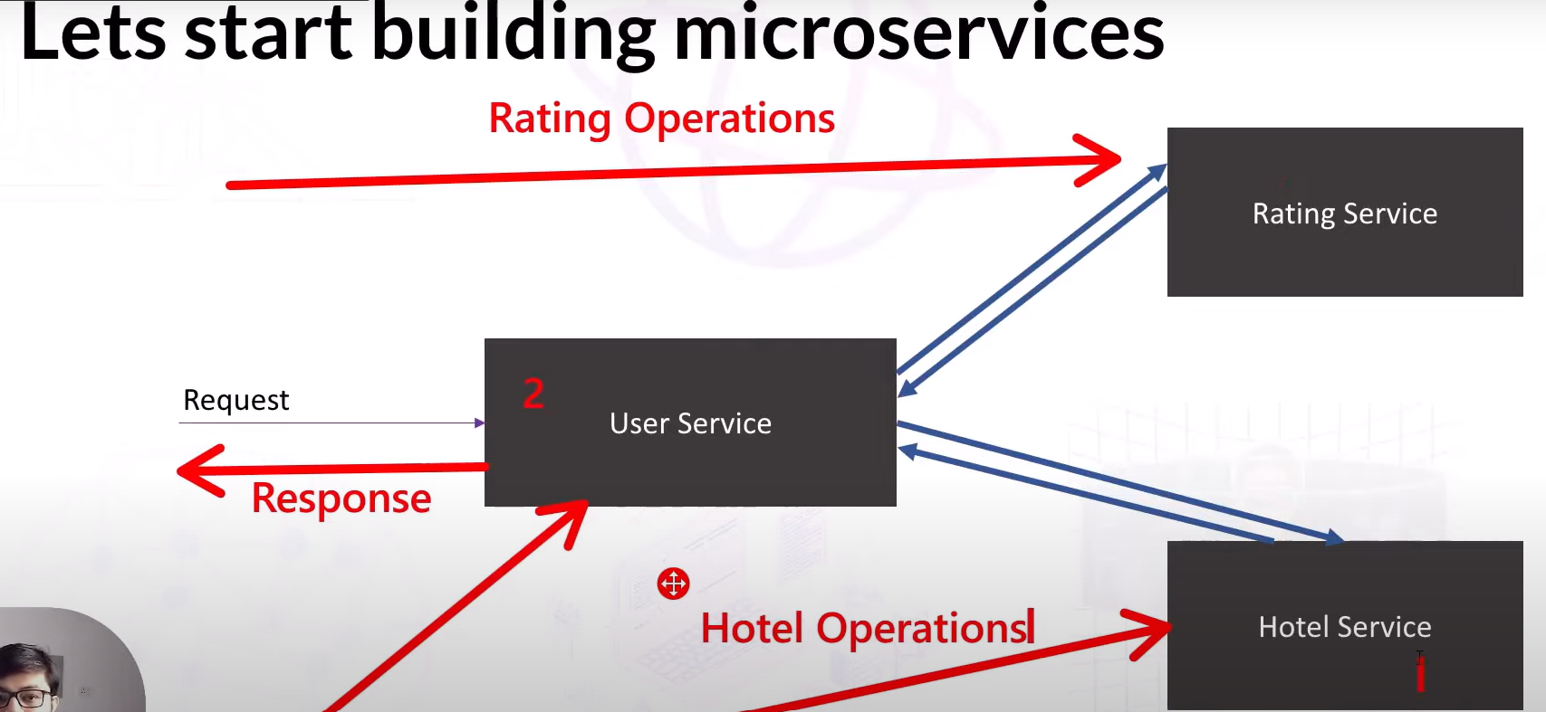

**User Service**

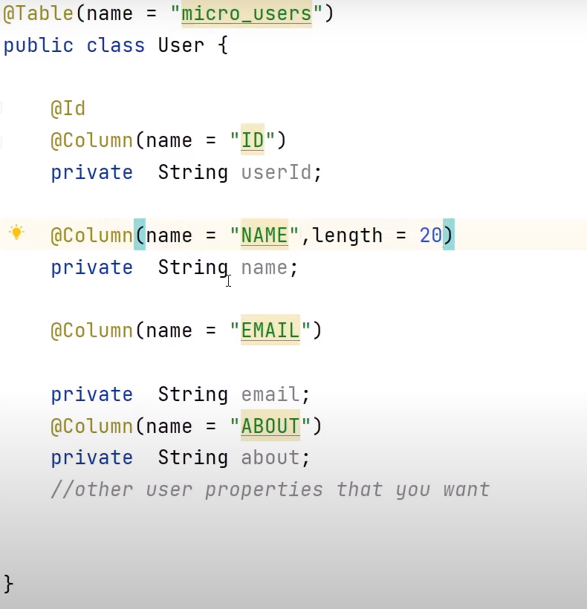

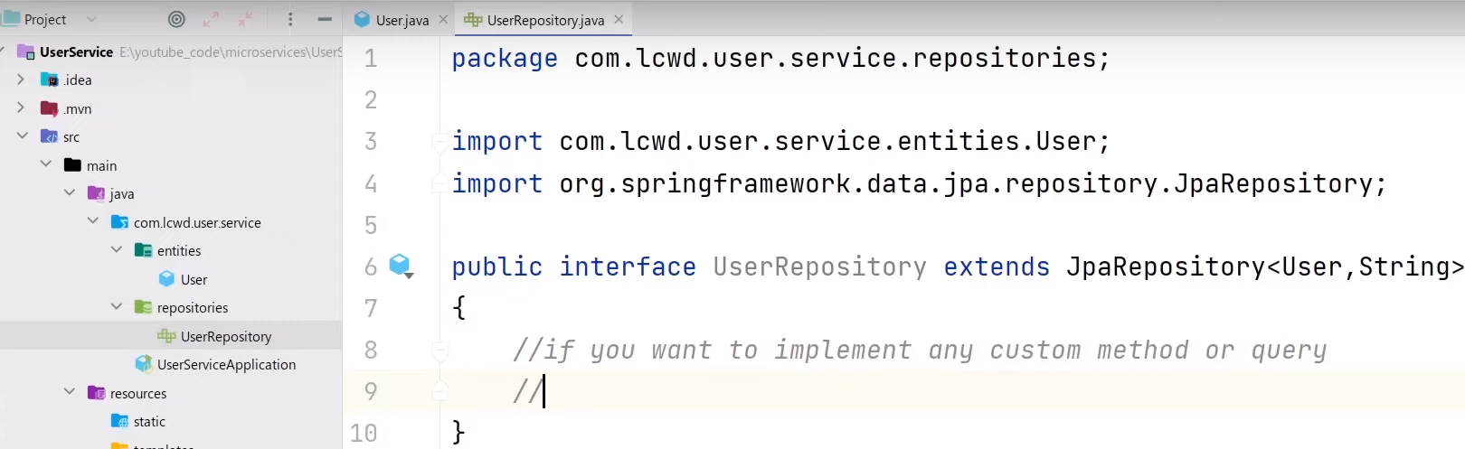

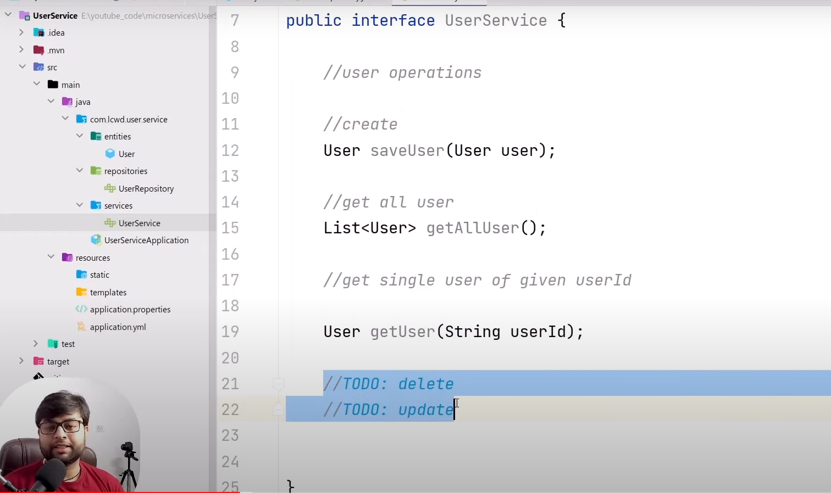

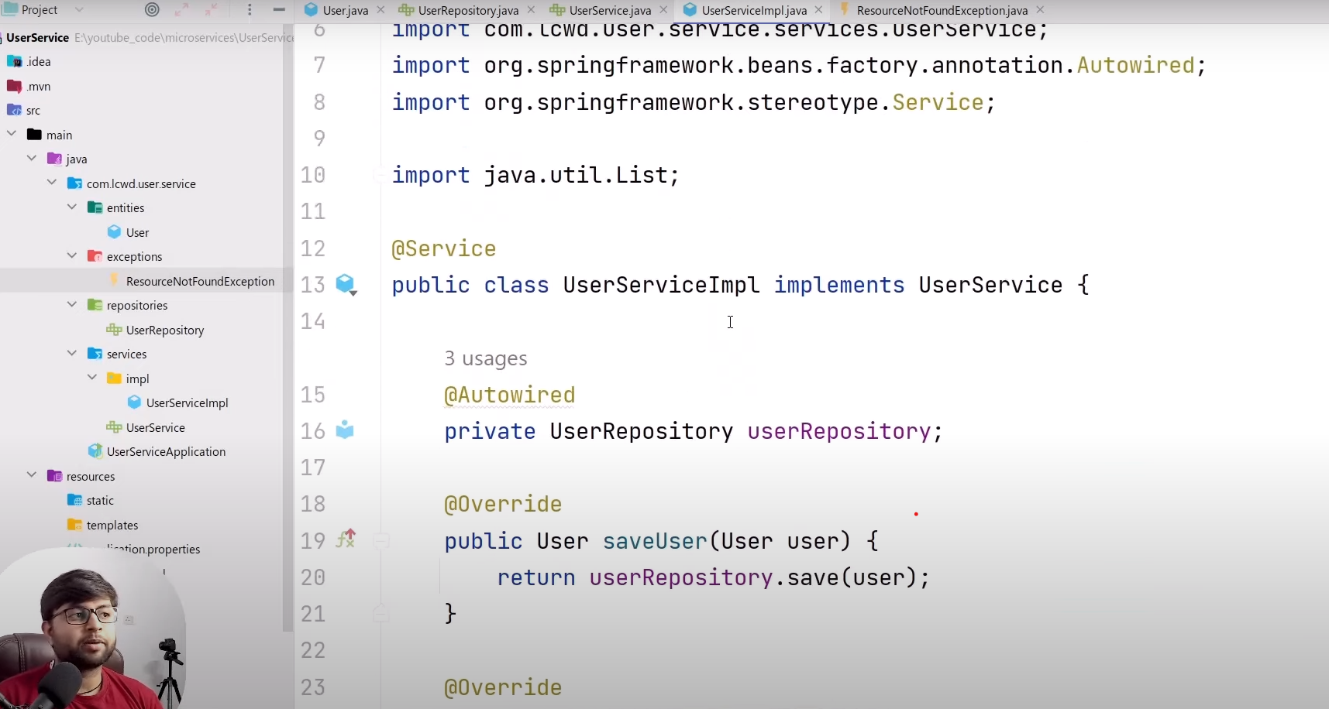

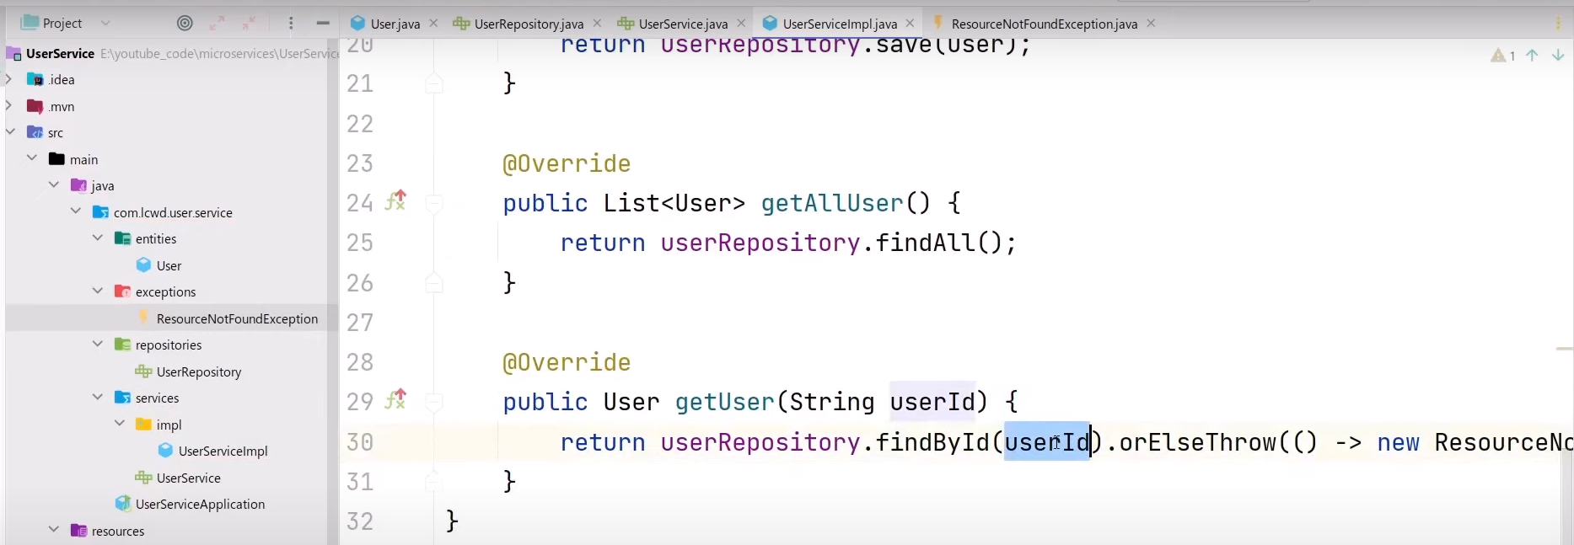

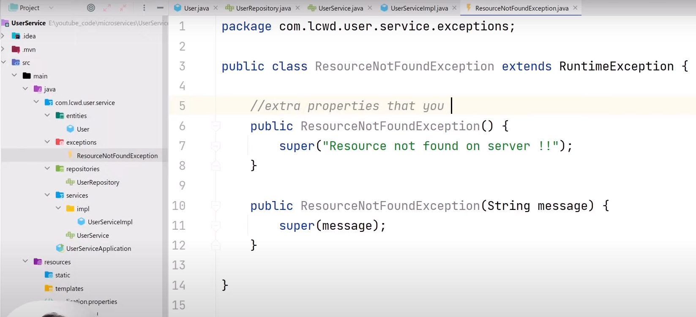

**We can handle exception globally as given below:**

**The annotation @ExceptionHandler is responsible for handling the exception.**

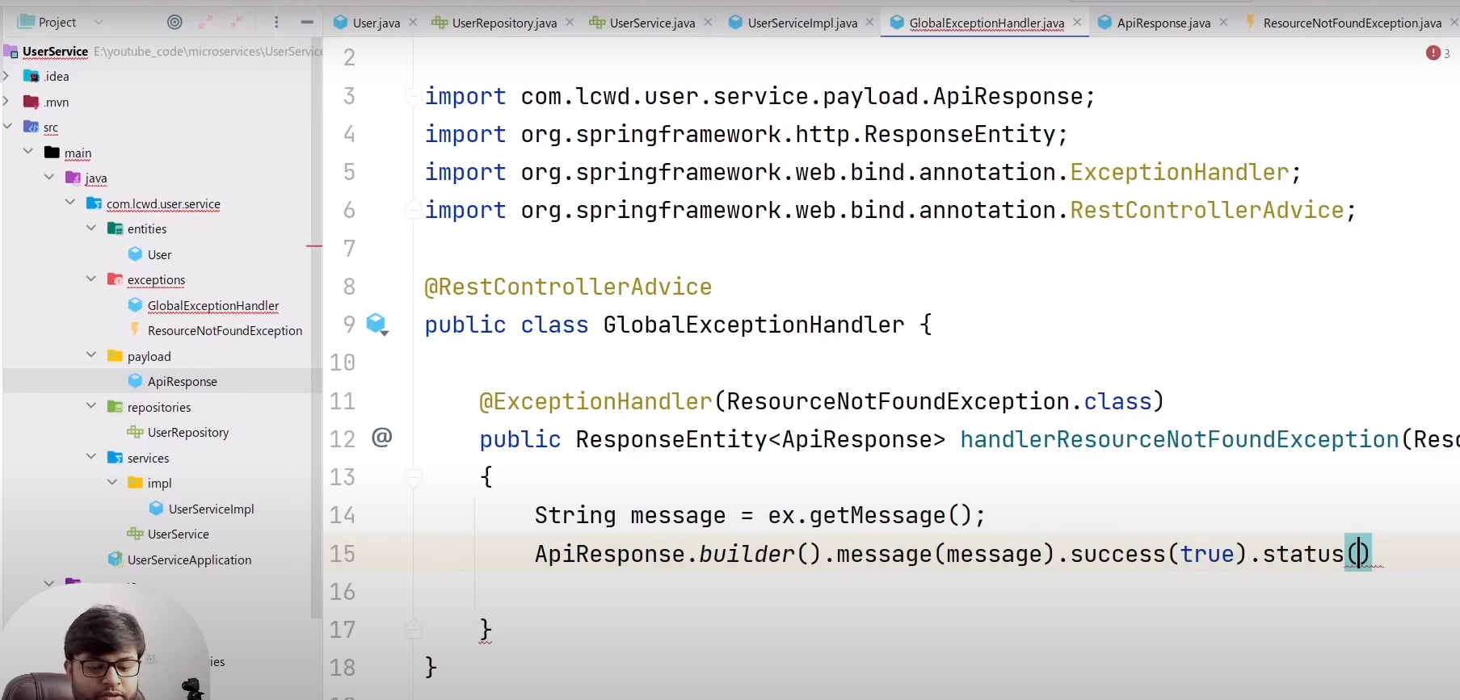

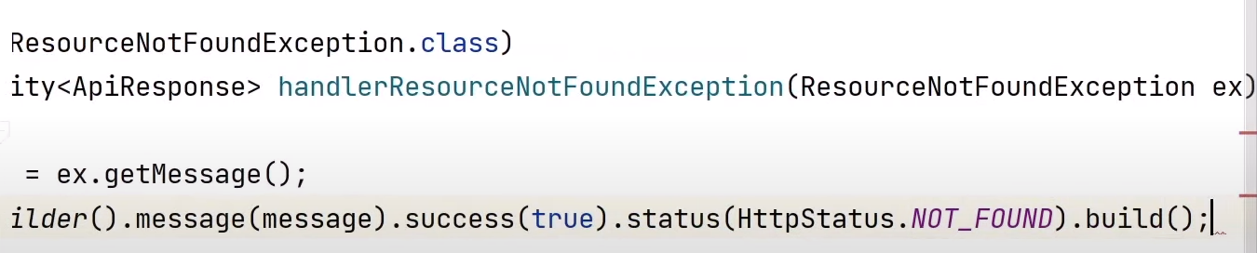

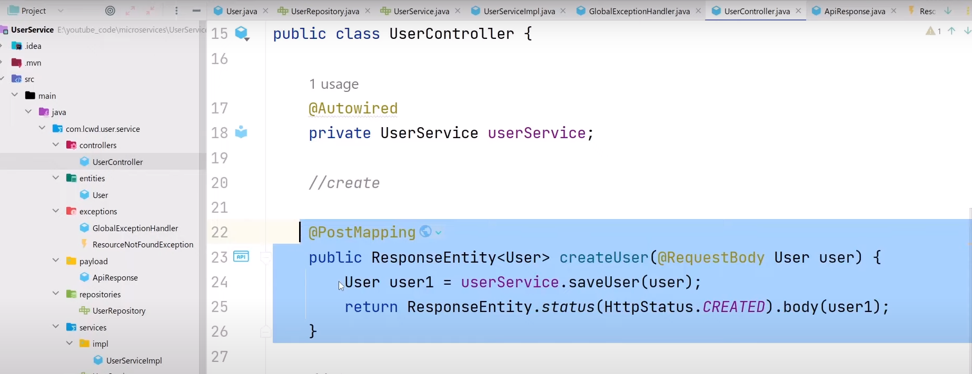

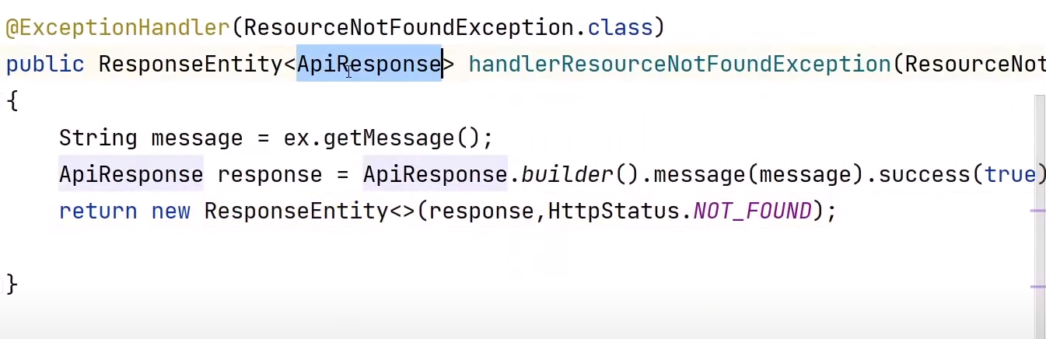

**Note: If you don’t want to set column in database of a table(Entity Class) then use @Transient on the above of data member.**

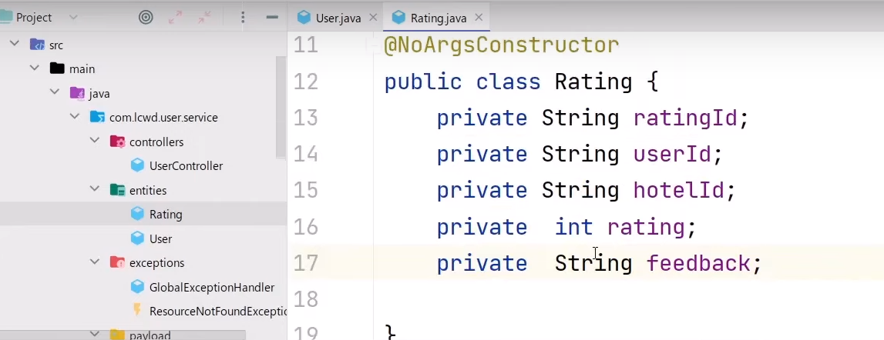

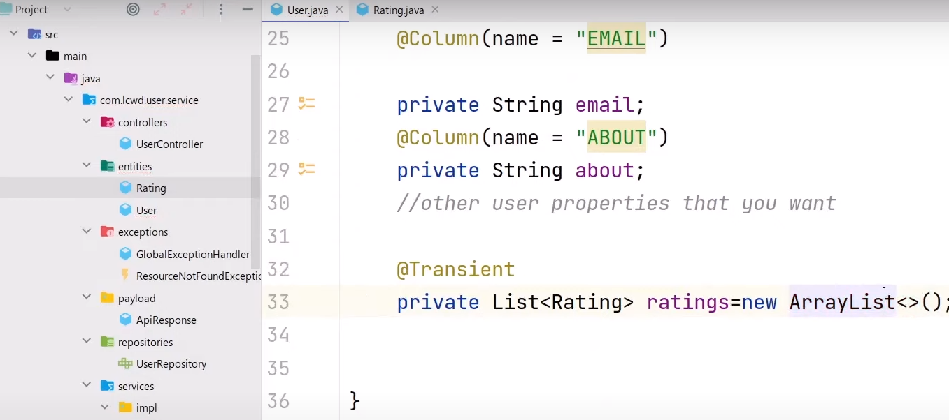

**Hotel Service**

**Below is hotel service implementation. Where there is HotelRepository, Entity and postgres database has been used for database operation.**

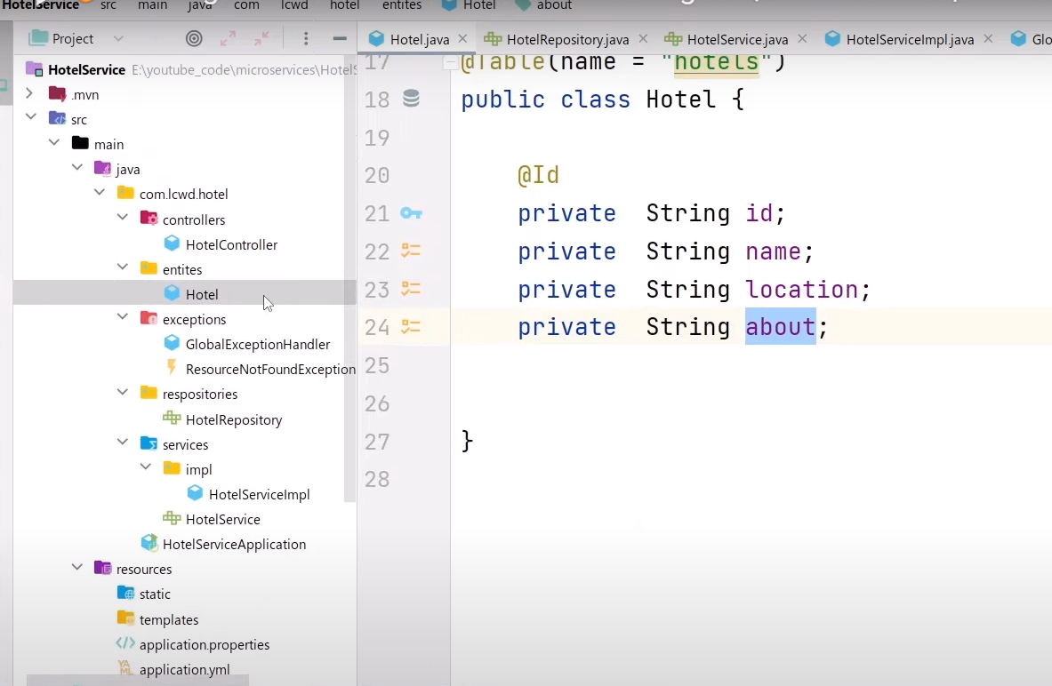

**Rating Service**

**Here we will use MongoDB**

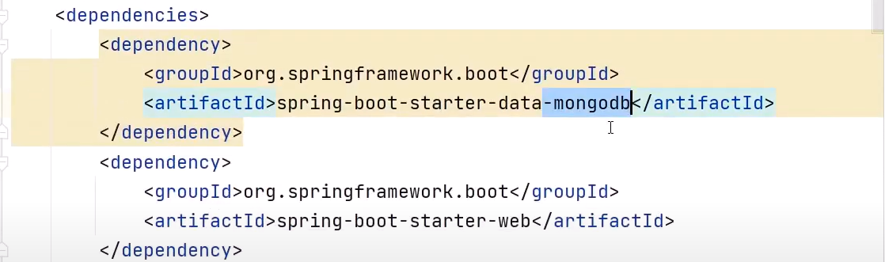

**We use @Document instead of @Entity to create table in mongoDB**

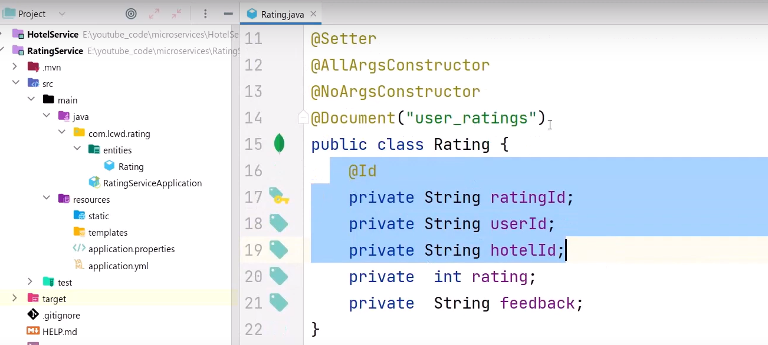

**Instead of JPARepository we use MongoRepository**

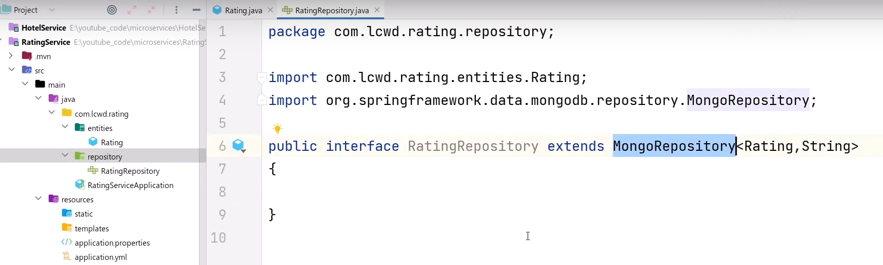

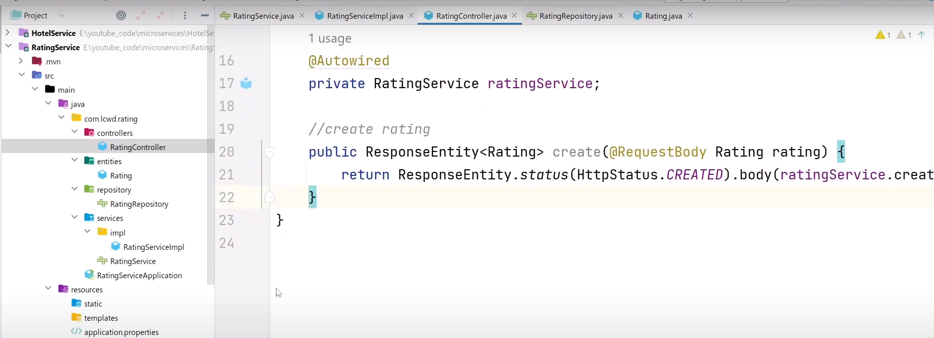

**Registry Service or Registry discovery**

**No need to give different address to call user service or Rating service or Hotel Service. Can be done this by using one address by service registry. It track all the information of each service like service is down or up etc.**

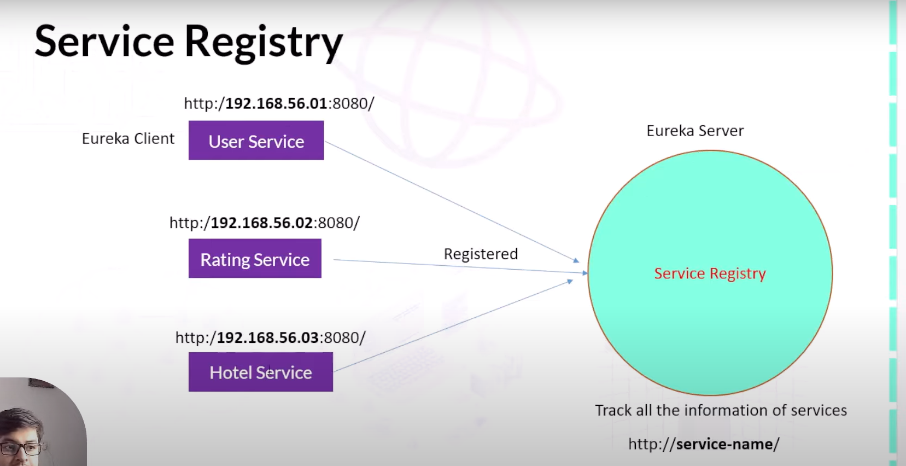

**Service Registry Project**

**We can use all features of spring web using Cloud Bootstrap dependency. We can remove web dpendency.**

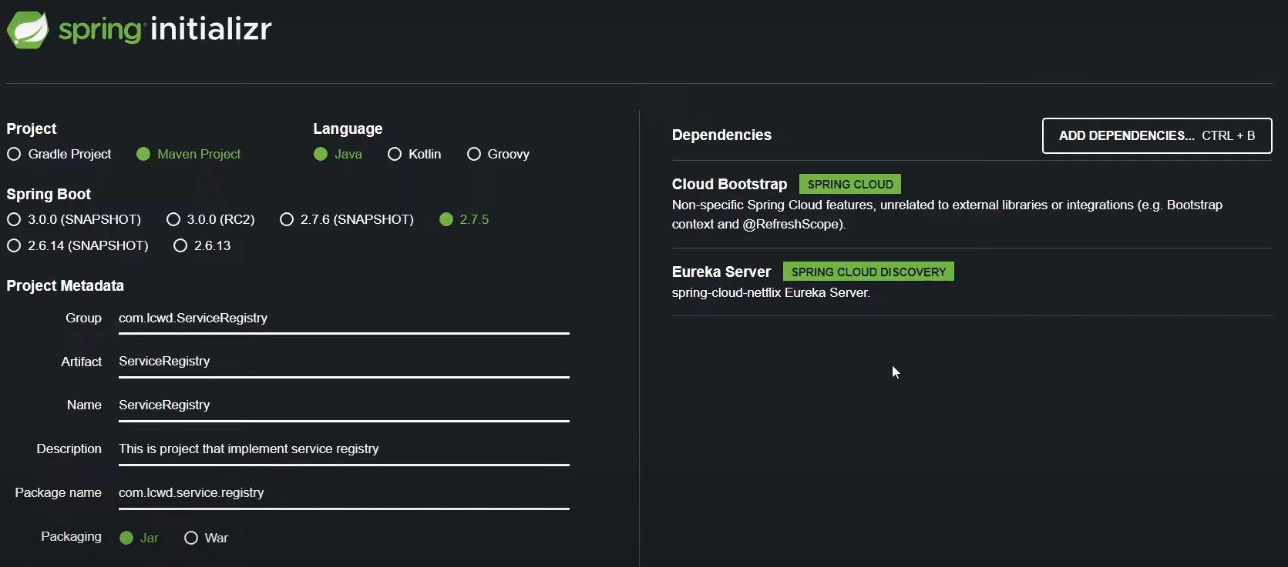

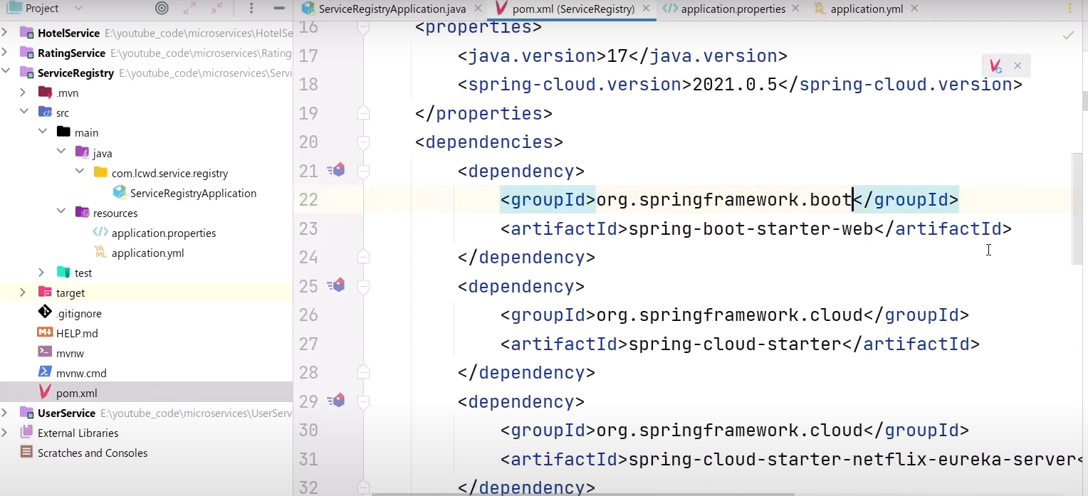

**This project is only for register all micro services on Eureka server. For this we need to enable Eureka server by @EnableEurekaServer**

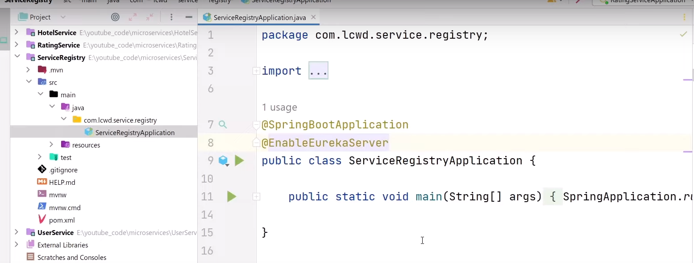

By default register-with-eureka is true. For say that this service is not micro service and this is service registry we false the registry-with-eureka and fetch registry.

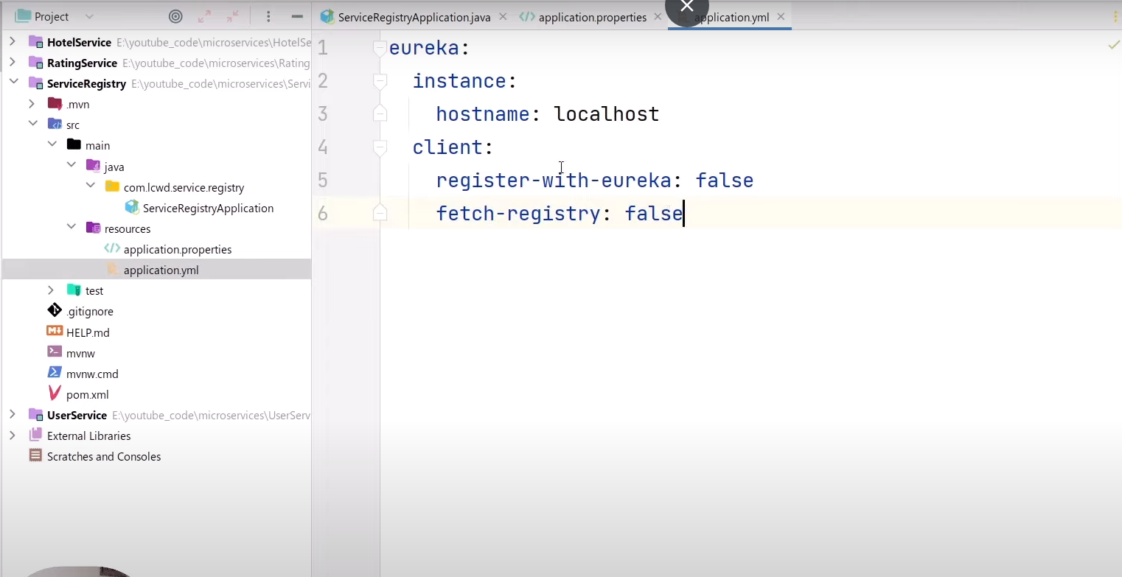

Add two more dependencies in each service (User service, Hotel service and Rating service).

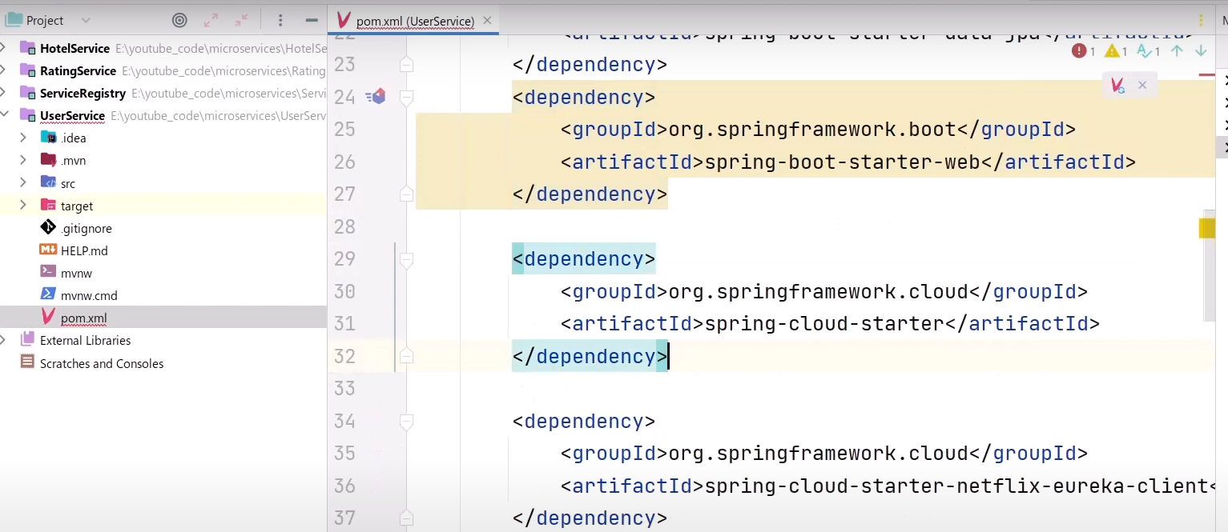

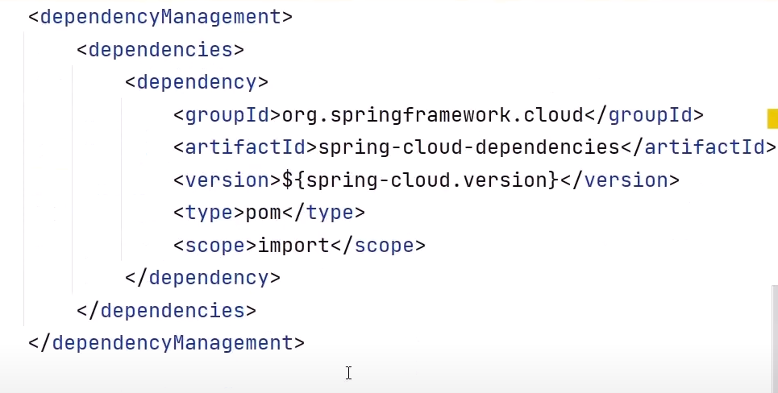

Also enable eureka client in each service

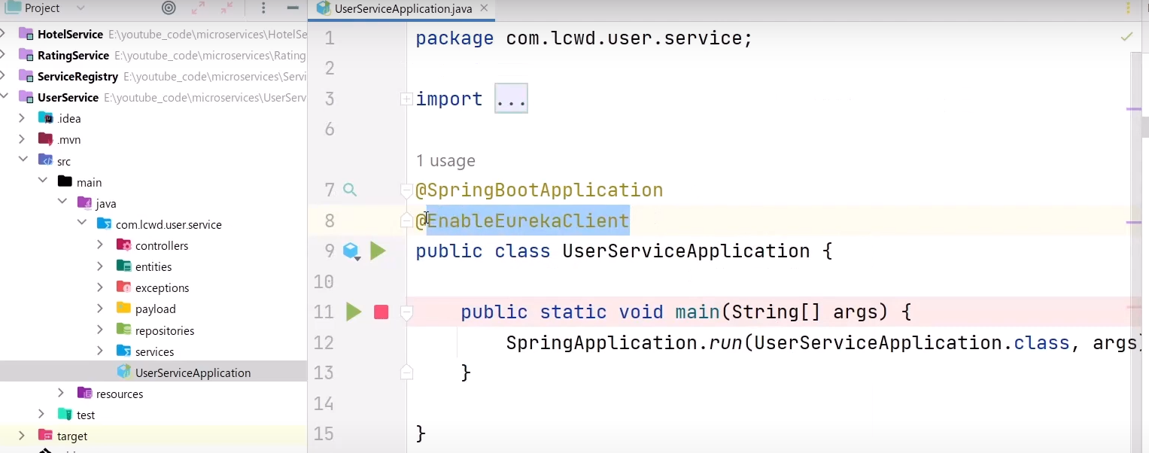

Also do below configuration in each service. And give the port of eureka service

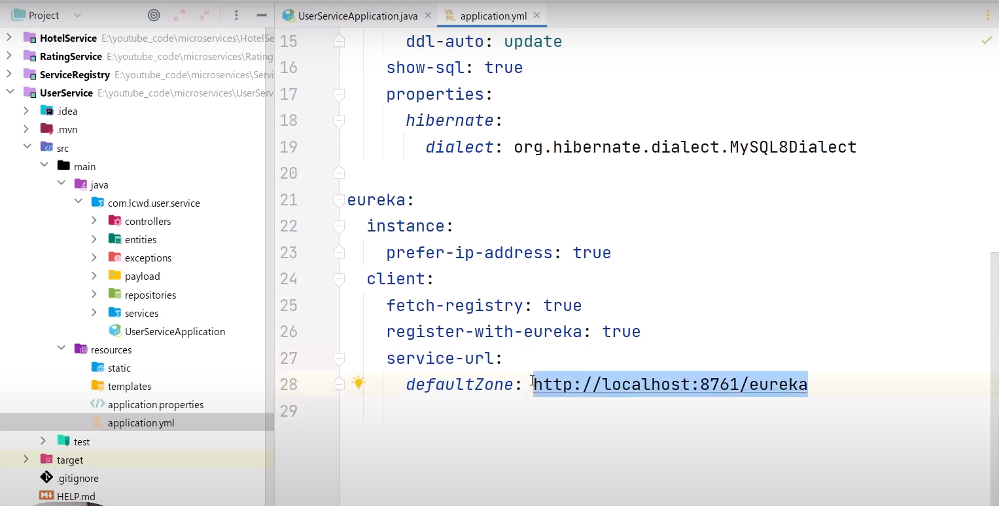

We can also give the name of each service in spring.application.name

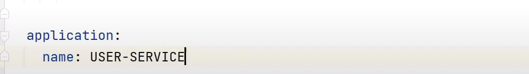

Eureka server will look like below:

